Tarlac State University
Dental Health Office

DENTAL RECORD

Registration Date:__________________
Valid Until:________________________
NAME:
ADDRESS:_____________________________________________
CELLPHONE #: _________________ YEAR & SEC.:_______________
DATE OF BIRTH: ________________ DEPARTMENT:______________
AGE: __________________________
STATUS:_______________________
GENDER:_______________________

Last Visit to a Dental Clinic: Treatment Done:____________________
(Other than the TSU Dental Clinic)
If never, State reason why:_________________________________

MEDICAL HISTORY:
_____Diabetes Height:
_____Heart Disease Weight:
_____Asthma Blood Pressure:
_____Epilepsy Pulse Rate:
_____Hypertension Resp. Rate:
_____Others (pls. Specify)___________________________________

In Case of Emergency Notify: ___________________________________________________
Address:____________________________________________________________________
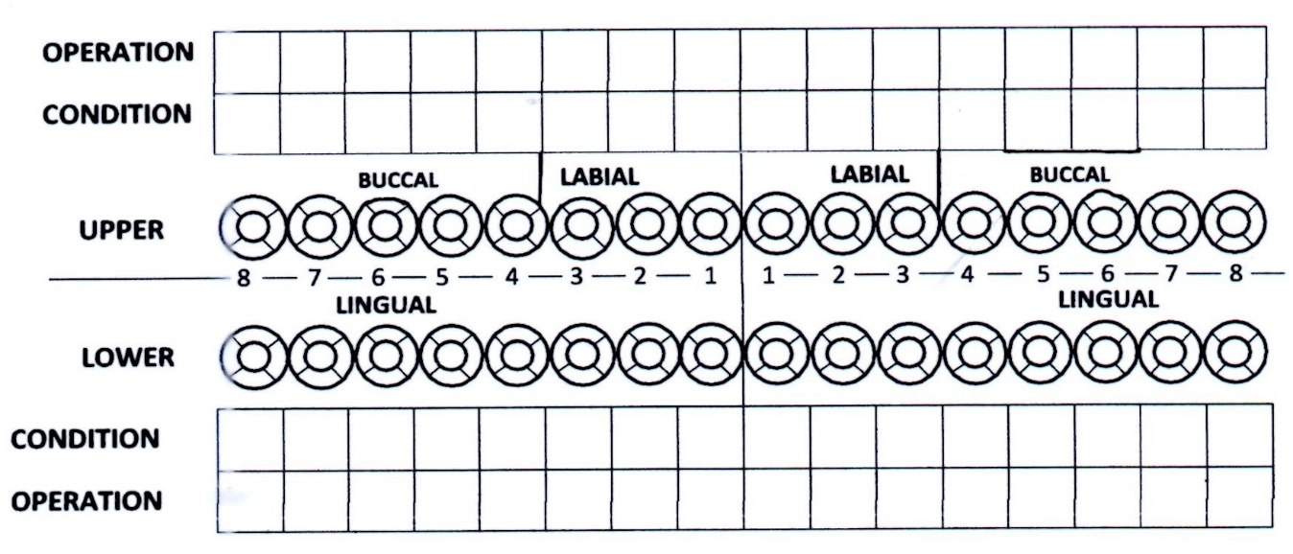
Telephone/Cell#: _____________________________________________________________

Treatment Plan: Next appointment date:

Form No.: TSU-DHO-SF-01 | Revision No. 01 | Effectivity Date : November 15, 2022 | Page 1 of 2

Treatment Record

Date | Tooth No. | Details of the Service Rendered | Signature

Form No.: TSU-DHO-SF-01 | Revision No. 01 | Effectivity Date : November 15, 2022 | Page 2 of 2

